CS 520: Object-Oriented Programming
Name: Dominic Tippabattuni & Ovidiu Mura
Submission Date: November 9, 2009; Fall/2009
Homework: Project Proposal
(Due Day: November 9, 2009 @ 16:00)
Team Name: Green Team
Team member: Dominic Tippabattuni, Ovidiu Mura
Context of the Project: A graphical representation in Smalltalk of the PDA (Pushdown
Automata)

We are planning to implement a project that will have a graphical representation in Smalltalk of the PDA (Pushdown Automata) using Pharo development environment. The purpose of the project is to give a good understanding how the Pushdown Automata works. A Montocello version will be on the squeaksource.com.

The project will have the following phases:

Phase 1

Visualize the language, L1 = {a^n b^n; n > 0}. We will visualize the states of the algorithm and transitions.
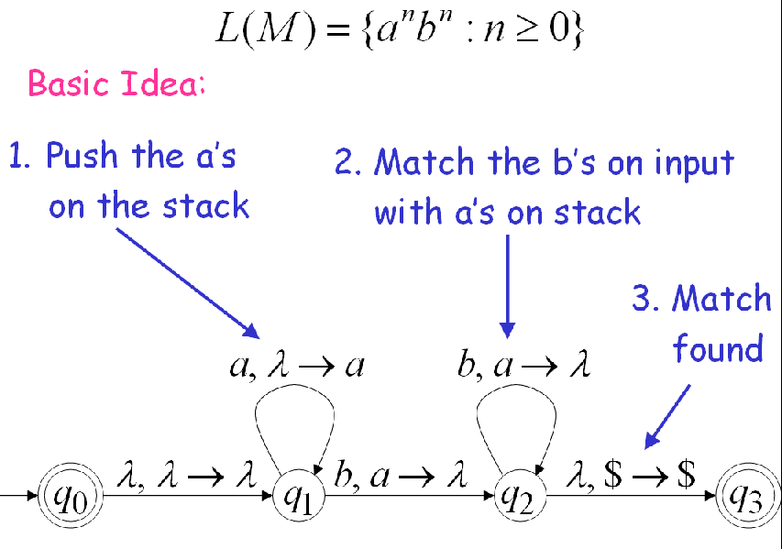
The screen will have a button that will cause the representation of the language to pop up. The states and the transitions will be represented very clear and easy to understand like in the image above.
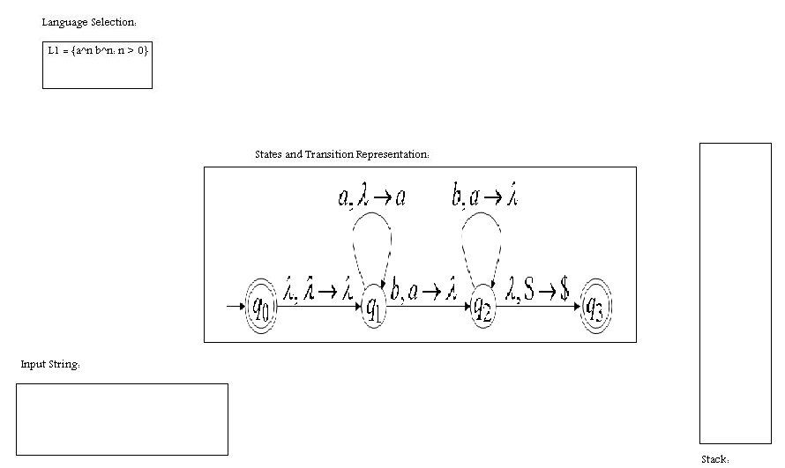

The user will enter a string and then will press the ‘ENTER’ key. The string will have a sequence of letters containing the letters ‘a’s and ‘b’s. The PDA will run and at the end it will pop up a message informing the user if the string is accepted or rejected.

Phase 2

In phase two, we will show the user the transition steps of PDA parsing the input string. The visualization of the transition steps will be accomplished by pressing the ‘Next’ button.
In the final state of the PDA the application will inform the user if the input string is accepted or rejected. The application will have a ‘Reset’ button which will reset the PDA to its initial state.
We will also visualize the stack operations (pop, replace, push, no change), that will be synchronized with the next button.

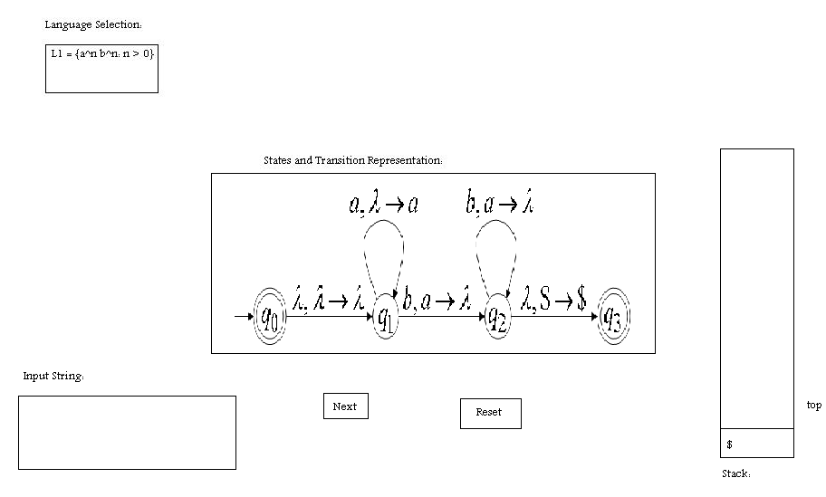

Phase 3

In phase 3, we will implement the PDA for another example representation of the PDA language. The same steps from phase one and phase two will be implemented for this language too.

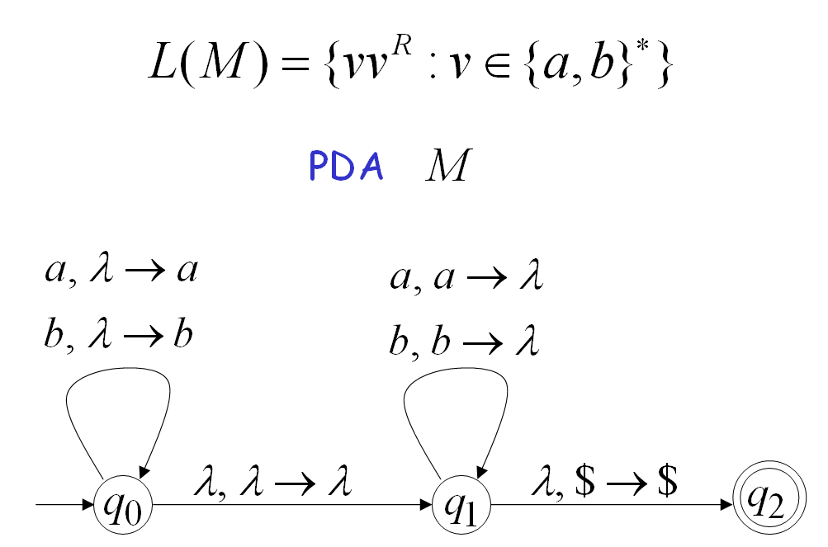
The user will be able to choose the language from the ‘Language Selection’ menu. The states’ representation will be displayed on the ‘States and Transition Representation’ part of the screen. The stack operation will be shown at run time when the user clicks the ‘Next’ button.

